Flood Risk Information and where to find it
The main Government website regarding flooding can be found here:
Flooding - GOV.UK
These pages are divided into:
- Popular links likes the check for flooding, long term flood risks, sign up to flood warnings
- Prepare for flooding (this includes templates for personal, business and community flood plans).
- During a flood
- After a flood
Long Term Flood Risks
Check the longer term flood risk for an area. This provides mapping for all types of flood risk:
Check the long term flood risk for an area in England - GOV.UK
For more information about the new Get Flood Warnings website go to: Launch of Get flood warnings | Engage Environment Agency
We have live data available to view on rain gauges, groundwater boreholes, river levels and tidal gauges. This data can be found here:
Live flood map - Check for flooding - GOV.UK
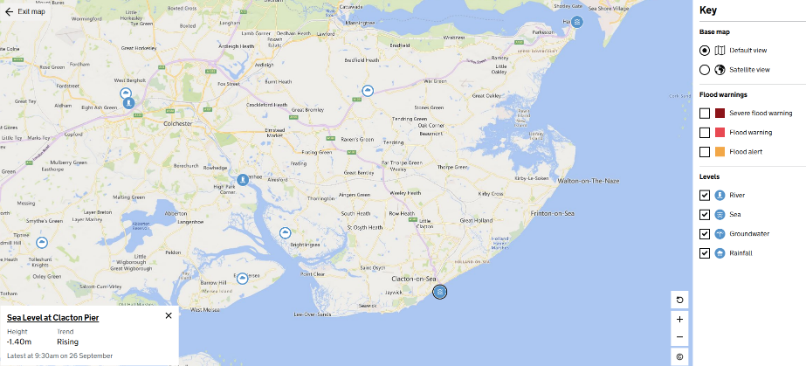

Any data from the Environment Agencyvcan be assessed by our Open Data Platform here:
Find open data - data.gov.uk
By using the search word ‘flood’ you can access Flood maps, data in spreadsheets and GIS map layers.
For More information on the Environment Agency Incident Hotline go to:
Report an environmental problem - GOV.UK
Other useful flood related resources are:
Home - Flood Mary
National Flood Forum – A charity to help, support and represent people at risk of flooding.

