

WEELEY PARISH COUNCIL
EMERGENCY PLAN

In the event of an emergency, it is the responsibility of Councillors
to have a hard copy of this plan for reference and to record
information relating to any incident.

Amendments to the Plan should be notified to The Parish Clerk
clerk@weeleyparishcouncil.gov.uk

Amended pages must be issued to all Councillors and
other contacts in the plan.

This Plan should be reviewed annually
Date of last review: 29th October 2024
Weeley Parish Council
Emergency Plan

Introduction
This plan is intended to be activated in the event of a major emergency in the parish of Weeley. It covers emergencies which may reasonably be foreseen, such as flooding, storms, heavy snowfall. For very rare occurrences, such as a major road traffic accident, train crash, air disaster, criminal activity it is expected that Tendring District Council and Essex County Council emergency plans will be activated. The emergency services will always be the first point of contact in an emergency.

The purpose of this plan is intended to build ‘Community Resilience’ so that the parish can use local resources and knowledge to help themselves during an emergency in a way that complements the local emergency services.
IF YOU ARE IN IMMEDIATE DANGER call 999
PLAN DISTRIBUTION LIST
Name | Role | Phone number/email address | Issued on
Catherine Boyer-Besant | Emergency Planning Officer Tendring District Council | 01255 686971  eplanning@tendringdc.gov.uk
Danny Botterell | Emergency Co-Ordinator and Parish Councillor | 07966 711106 cllr.dbotterell@weeleyparishcouncil.gov.uk
Steve Gunter | Deputy Co-Ordinator and Parish Clerk | 07368 925194  clerk@weeleyparishcouncil.gov.uk
Kevin Green | Deputy Co-Ordinator and Parish Councillor | 07900 347231  cllr.kgreen@weeleyparishcouncil.gov.uk
Christine Hamilton | Parish Council Chair | 01255 831590  07785 900007  cllr.chamilton@weeleyparishcouncil.gov.uk
Vicky Cauvain | Parish Councillor | 07850 974240  cllr.vcauvain@weeleyparishcouncil.gov.uk
Gilliane Foster | Parish Councillor | 01255 830084  cllr.gfoster@weeleyparishcouncil.gov.uk
Terry Spong | Parish Councillor | 01255 830710  07770 868970  cllr.tspong@weeleyparishcouncil.gov.uk
Jenny Beady | Parish Councillor | 07591 338823  cllr.jbeady@weeleyparishcouncil.gov.uk
Liz Fitzpatrick | Parish Councillor | 07749 220948 cllr.lfitzpatrick@weeleyparishcouncil.gov.uk
Kevin Millar | Parish Councillor | 07738 998924  cllr.kmillar@weeleyparishcouncil.gov.uk

Emergency Contact List

Name: Danny Botterell | Name: Steve Gunter | Name: Kevin Green
Emergency Co-Ordinator and Parish Councillor | Deputy Emergency Co-Ordinator and Parish Council Clerk | Deputy Emergency Co-Ordinator and Parish Councillor
07966 711106 | 07368 925194 | 07900 347231
Email:  cllr.dbotterell@weeleyparishcouncil.gov.uk | Email:  clerk@weeleyparishcouncil.gov.uk | Email:  cllr.kgreen@weeleyparishcouncil.gov.uk
Address:  Jolley Cottage, Clacton Road Weeley Heath CO16 9DR | Address:  Chota Gur, The Street, Bradfield  CO11 2UU | Address:  35 St Andrews Road, Weeley CO16 9HR

TENDRING DISTRICT COUNCIL
Careline | 01255 222722  Out of Hours: 01255 222022 | Emergency calls – Careline (this should be the first contact during an emergency)
Emergency Planning Officer | 01255 686971  07468 709746 | Catherine Boyer-Besant

WEELEY PARISH COUNCIL CONTRACTORS
Goldacre Contracting | 07793 057 658 | Ground's maintenance contractor
AD Mitchell Electrical Contractors | 07803 618 915 | Council’s streetlights

OTHER EMERGENCY NUMBERS
Police  Ambulance  Fire | 999
Environment Agency | 0800 80 70 60 | Incident hotline
National Grid | 0800 111 999 | The National Grid maintains and supports the national gas and electricity supply.
UK Power Networks | 0800 31 63 105 or 105 | For dangerous problem with electricity cables
Affinity Water | 0345 357 2407 | Burst water pipes etc.
Anglian Water | 03457 145 145 | Sewerage etc.
Essex County Council | 0845 603 7631  0300 123 5000 | Highway Incident’s

Local skills and resources assessment

Skill Resource | Who? | Contact details | Location
Medical supplies |  | 01255 862457  01206 250120  01255 861329 | The Lighthouse Pharmacy, 19-21 The Street,  Little Clacton CO16 9LQ  The Green Pharmacy, The Green,  Great Bentley CO7 8PJ  Mansfield Chemist Shop, Maidshead Parade,  High Street, Thorpe-le-Soken. CO16 0DY
First aider | Kevin Millar  Vicky Cauvain  Danny Botterell | 077389 98924 | Weeley
Defibrillator |  | n/a  01255 830384  01255 860062 | Weeley Village Hall (outside near front door) CODE 1628  White Hart Public House, Clacton Road, Weeley CO16 9ED  National Animal Welfare Trust, The Street, Little Clacton CO16 9LG  Women's Institute Hall. High Street Thorpe-le-Soken CO16 0EF
4x4 owner/driver | Terry Spong  Kevin Green  Christine Hamilton | 01255 830710  07770 868970  07900 347231  01255 831590  07785 900007 | Mascot, 34 Rectory Road, Weeley Heath, CO16 9AX  35, St Andrew’s Road, Weeley CO16 9HR SHOULD BE CO16 9HR  Margaret Cottage, Thorpe Road, Weeley, CO16 9JL
Cherry Picker | Danny Botterell | 07966 711106 | Jolley Cottage, Clacton Road Weeley Heath CO16 9DR
Lorries/ tractors | Will Leiper  Simon Partridge | 01255 831083  07753 685484  01255 830397 | Paynes Turf/Hilltop Garden Centre, Clacton Road,  Weeley CO16 9DN  Lodge Farm, Church Lane, Weeley  Heath CO16 9AT  Oak Farmhouse, Mill Lane, Weeley Heath CO16 9BZ
Chainsaw owner | Terry Spong | 01255 830710  07770 868970 | Mascot, 34 Rectory Road, Weeley Heath, CO16 9AX
Water/food supplies |  | 01255 830433  01255 830070  01255 830403  01255 830463  01255 831083  01255 831030 | Weeley Post Office and Convenience Store,  53 The Street, Weeley CO16 9JD  Gaunt Bakers, The Street, Weeley CO16 9JD  Weeley Bridge Caravan Park, Clacton Road,  Weeley CO16 9DH  The Cabin, Homestead Caravans Thorpe Road,  Weeley CO16 9JN  Hilltop Garden Centre Clacton Road,  Weeley CO16 9DN  BP garage, Crown Green Roundabout, Weeley CO16 9JT
Church of England Churchwardens | Sandra De Roy  Pearl Byford | 07891 986442  01255 831124 | Broomcroft, Honeypot Lane, Weeley Heath, CO16 9BQ  20, Bentley Road, Weeley Heath, CO16 9DT
Plymouth Brethren | Andrew Evershed |  | Rapid Relief Team (RRT), the charitable arm of the Plymouth Brethren Christian Church and are available to be called on 24/7 in times of emergency to assist with supporting and providing hot food and snacks to emergency workers. They can be contacted either through the website https://rrtglobal.org/gb/ or you can drop me a line if their services are required.  We also have a salt/grit bin just inside the side gate of our Weeley Hall which may be used to keep the adjacent footpaths clear in the event of snow and frost.
Church of Jesus Christ of Latter-Day Saints | Nick Clark, Branch President | 07751755229 | Tendring Branch - (based in Weeley)
Salvation Army | Major David & Katerina Lennox | 01255 423328 | Clacton Branch, 103 Old Road, Clacton-on-Sea CO16 3AN
Veterinary assistance |  | 01255 860555  01255 441441  01206 842224 | Kinfauns Veterinary Centre, The Street,  Little Clacton CO16 9LG  Weeley Veterinary Centre, 26 Colchester Road  Weeley, CO16 9JT  VETS NOW EMERGENCY SERVICE COLCHESTER  70 Brinkley Lane Highwood Colchester CO4 9XE
Voluntary organizations | Maureen Stock  Shirley White | 01255 830115  07941 099147 | Weeley Woman’s Institute  Weeley Community Care 7, Fields Close, Weeley, CO16 9DS
Cubs / Scouts | Heather Baldwin | 07900486632 | Scout HQ, Weeley Playing Field / E Mail hjb107@hotmail.com  Trained First Aider
Accommodation |  | 0871 527 254 | Premier Inn, Crown Green Roundabout,  Weeley CO16 9AD - 62 rooms, some family
Cooking facilities |  | 01255 830234  01255 831430  01255 830361  01255 830463  01255 831116  01255 831234 | St. Andrew’s School, Clacton Road, Weeley CO16 9DH  The Bowling Green, Crown Green Roundabout,  Weeley CO16 9AD  The Black Boy, Thorpe Road, Weeley CO16 9JJ  The Cabin, Homestead Caravans Thorpe Rd, Weeley CO16 9JN  McDonalds 1 Colchester Road, Weeley CO16 9AD  Ford Barns, Crown Lane, Tendring, CO16 0BH
Fuels |  | 01255 831030  01255 831083  01255 830403  01255 830229 | BP garage (petrol/diesel/LPG) Crown Green Roundabout, Weeley CO16 9JT  Hilltop Garden Centre Clacton Road, Weeley CO16 9DN(LPG)  Weeley Bridge Caravan Park Clacton Road,  Weeley CO16 9DK (LPG)  Homestead Caravans Thorpe Road,  Weeley CO16 9JN (LPG)
Generators | Terry Spong  Danny Botterell | 01255 830710  07770 868970  07966711106 | Mascot, 34 Rectory Road, Weeley Heath, CO16 9AX  Jolley Cottage, Clacton Road Weeley Heath CO16 9DR
Lifting/ welding/ cutting gear |  | 01255830623  01255 830428  01255 831000  01255 831322 | Hillside Motors Clacton Road, Weeley, CO16 9DN  Greenspeed Autostylists, Norwood Lodge Farm, Bentley Road, Weeley Heath CO16 9BX greenspeed@btinternet.com  D Salmon Cars 12 Colchester Road, Weeley CO16 9JD  D Piper Motors Clacton Road, Weeley CO16 9DN
Plumber | M  Hopkins  LR Plumbing & Heating  SAC Plumbing | 01255 861590  01255 863655  07727 669 858  07860 684045 | 21 Frinton Rd, Thorpe-le-Soken, Clacton-on-Sea  2 Edward Close, Little Clacton, Essex, CO16 9PR  Longcroft Cottage, Bentley Road, Weeley Heath CO16 9BX
Glazing | Nick Coe | 01255 831426 | 15 Fields Close, Weeley Heath
Builder | Terry Spong | 01255 830710  07770 868970 | Mascot, 34 Rectory Road, Weeley Heath, CO16 9AX
Electrician | Spence Elec  NewTech | 07939 554197  01255 886422  01255 423345 | Harwich  Team of 4 electricians under the management of Cllr. Danny Botterell
Walkie talkie/ Radio amateurs | Danny Botterell  Graham Bloyce,  Secretary | 07966 711106  01255 426764 | Weeley Bridge Breakers  [RAYNET is used by TDC during an emergency, however  Other alternatives could be useful if the Parish was isolated  and other forms of communication were down.]
Communication – BBC Essex |  | 01245 616066  0800 111 4041  81333 | Radio News Team  On-air programme number  TEXT  In an emergency encourage local residents to  “Go in, stay in, tune in”  103.5FM or 729MW

telephone tree
The phone tree works as a pyramid, with the coordinator at the top making the first call to two or more people. In turn, they call an assigned set of people and so on, until the tree is complete.

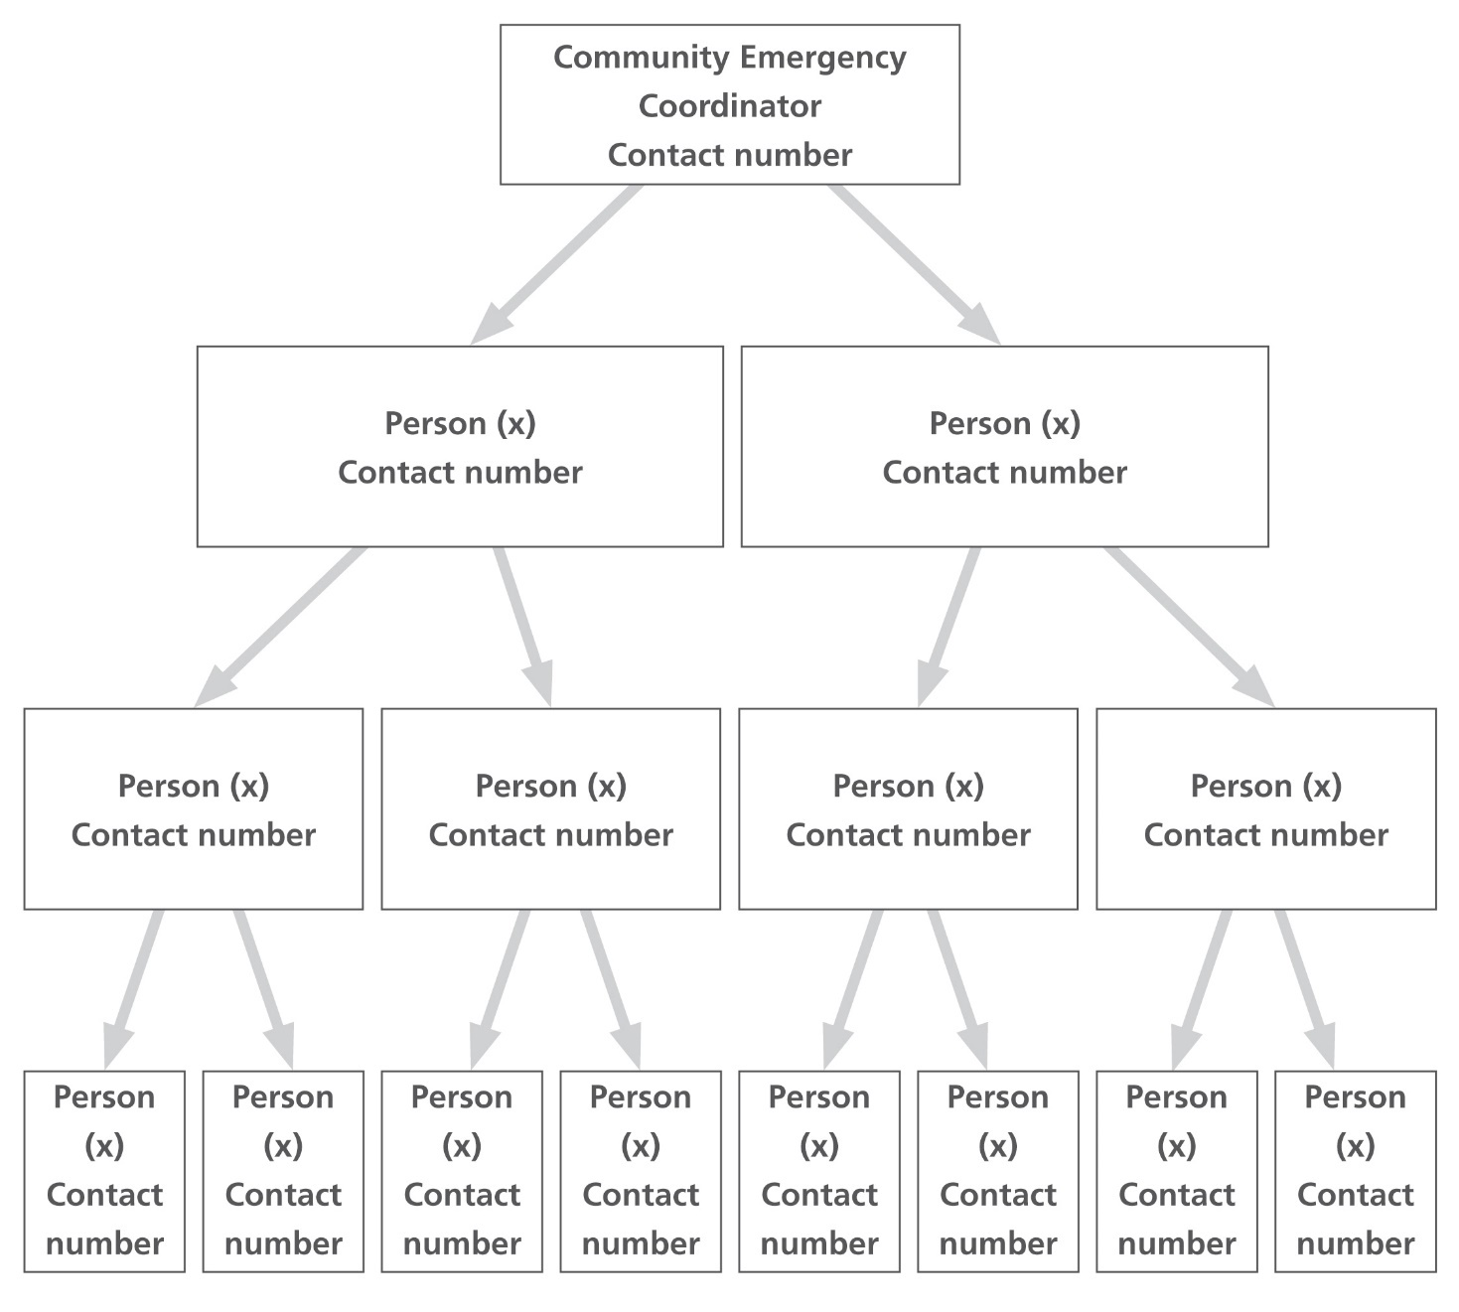
Jenny Beady
07900 888488

Vicky Cauvain
07850 974240

Gillane Foster
01255 830084

Christine Hamilton
07785 900007
01255 831490

Liz Fitzpatrick
07749 220948

Terry Spong
01255 830710
07770 868970

Kevin Millar
07738 998924

Deputy Emergency
Co-Ordinator
Kevin Green
07900 347231
Deputy Emergency
Co-Ordinator
Steve Gunter
07368 925194

Emergency Co-Ordinator Danny Botterell
07966 711106

EMERGENCY GRAB BAG

A ‘grab bag’ is held by the Emergency Co-Ordinator. It contains the following items:
- Wind up radio
- Wind up torch
- Energy drink
- Bottled water
- Emergency light sticks
- Multi tool
- Clip board
- Head torch
- Waterproof notebook
- Permanent marker
- Pen/Pencil
- Scissors
- Hand sanitizer
- High visibility vests x 2
- Disposable camera
- Dust masks
- Burn kit
- First aid kit
- Hazard tape
- Foil blankets
- Fog horn
- Road Atlas
- Jump leads
- Snow shovel
- De-icer
- Sunscreen
- Megaphone

The grab bag must be checked every six months to ensure that items with a ‘used by date’ are still in date. Out of date items must be replaced.

L0CAL RISK ASSESSMENT

Risks | Impact on community | What can Community Emergency Group do to prepare?
Risk of flooding in Weeley, especially in Gutteridge Hall Lane area | Access to properties in flooded area  Damage to property | - Add information on home flood defence’s to website  - Display Environment Agency flood map on noticeboards and website  - Raise awareness of flood risk via parish council communications  - Work with local emergency responders to see if they can help with distribution of flood warnings and any evacuation and reception centre establishment required  - Promote the use of grab bags
Risk of falling trees due to storms | Roads blocked | - Ensure that condition of vulnerable trees is monitored and reported to the appropriate responsible body  - Ensure that Highways contact numbers are up to date  - Note names of local people who have the right equipment and skills to help in an emergency. Need to check each year that those willing to help are still in a position to do so
Risk of heavy snowfall or icy conditions | Residents unable to leave home | - Encourage good neighbourliness  - Ensure salt supplies are adequate and stored at accessible locations in Weeley and Weeley Heath  - Publicise locations of salt bins
Protracted disruption to power supplies, water or telecommunications | Vulnerable residents unable to maintain heat, light, drinking water, communication | - Encourage good neighbourliness  - Encourage vulnerable residents, including those with medical conditions, to register in advance with power companies  - Promote use of grab bags
Major accident or incident in Weeley or immediate area | Natural desire of community to help  Media focus on community | - Identify in advance who will be the main liaison point with other local authorities and any other appropriate authority
Nationwide pandemic | Vulnerable residents unable to access necessary services | - Maintain awareness of older residents and others with disabilities or long-term medical conditions.
Establishments needing help | Care Homes, Sheltered Housing etc | - Kate Daniels  - White Heathers Care Home, Clacton Road, Weeley - 01255 830502  - Little Millfields Care Home, Mill Lane, Weeley Heath – 01255 830425

First steps in an emergency
Follow the instructions below when the plan is activated.
 | Instructions | Tick
1 | Call 999 (unless already alerted)
2 | Ensure you are in no immediate danger
3 | Contact the Community Emergency Group and meet to discuss the situation
4 | Establish the scope of the emergency
5 | Identify who is likely to be affected
6 | Allocate tasks
7 | Decide on communication strategy
8 | Decide on review/ check-back process
9 | All Councillor’s should be kept updated via the Telephone Tree

DURING AND AFTER an emergency
Follow the instructions below when the plan is activated.
 | Instructions | Tick
1 | Keep a log of your actions during the incident
2 | Record any actions you have taken
3 | Record who you spoke to and what was said
4 | Report your actions to the Emergency Co-Ordinator
5 | Keep notes of any problems where lessons can be learned for the future
6
7

Draft Community Emergency Group first meeting agenda

Example Community Emergency Group Emergency Meeting Agenda
Date:
Time:
Location:
Attendees:

1. What is the current situation?
You might want to consider the following:

Location of the emergency. Is it nearby:
- A school?
- A vulnerable area?
- A main access route?
- Type of emergency
- Is there a threat to life?
- Has electricity, gas or water been affected?
Are there any vulnerable people involved?
- Elderly
- Families with children
- Non-English-speaking people

What resources do we need?
- Food?
- Off-road vehicles?
- Blankets?
- Shelter?

2. Establishing contact with the emergency services

3. How can we support the emergency services?

4. What actions can safely be taken?

5. Who is going to take the lead for the agreed actions?

6. Any other issues?

Actions agreed with local authority in the event of an evacuation
Tendring District Council will co-ordinate any request by the blue light services, usually the Police, and should be able to advise what role the Community Emergency Group can play in the particular circumstances of the emergency i.e.

- door knocking
- relay of emergency messages
- helping at the rest centre
- identifying those who may need extra help to move to safety.

Alternative arrangements for staying in contact if usual communications have been disrupted.

Mobile phones will be the default method of staying in touch. However, a major emergency could mean that mobile phone networks are overloaded. Land line numbers will be provided for emergency group members.
Walkie talkie/ Radio amateurs - Weeley Bridge Breakers - Graham Bloyce, Secretary - 01255 426764

Use of e-mail and Facebook as an alternative method of communication to be considered depending on the specific emergency.

The village hall will be the default physical rendezvous point. All ‘hard’ information relating to the emergency will be kept there.

WEELEY PARISH STREET MAP

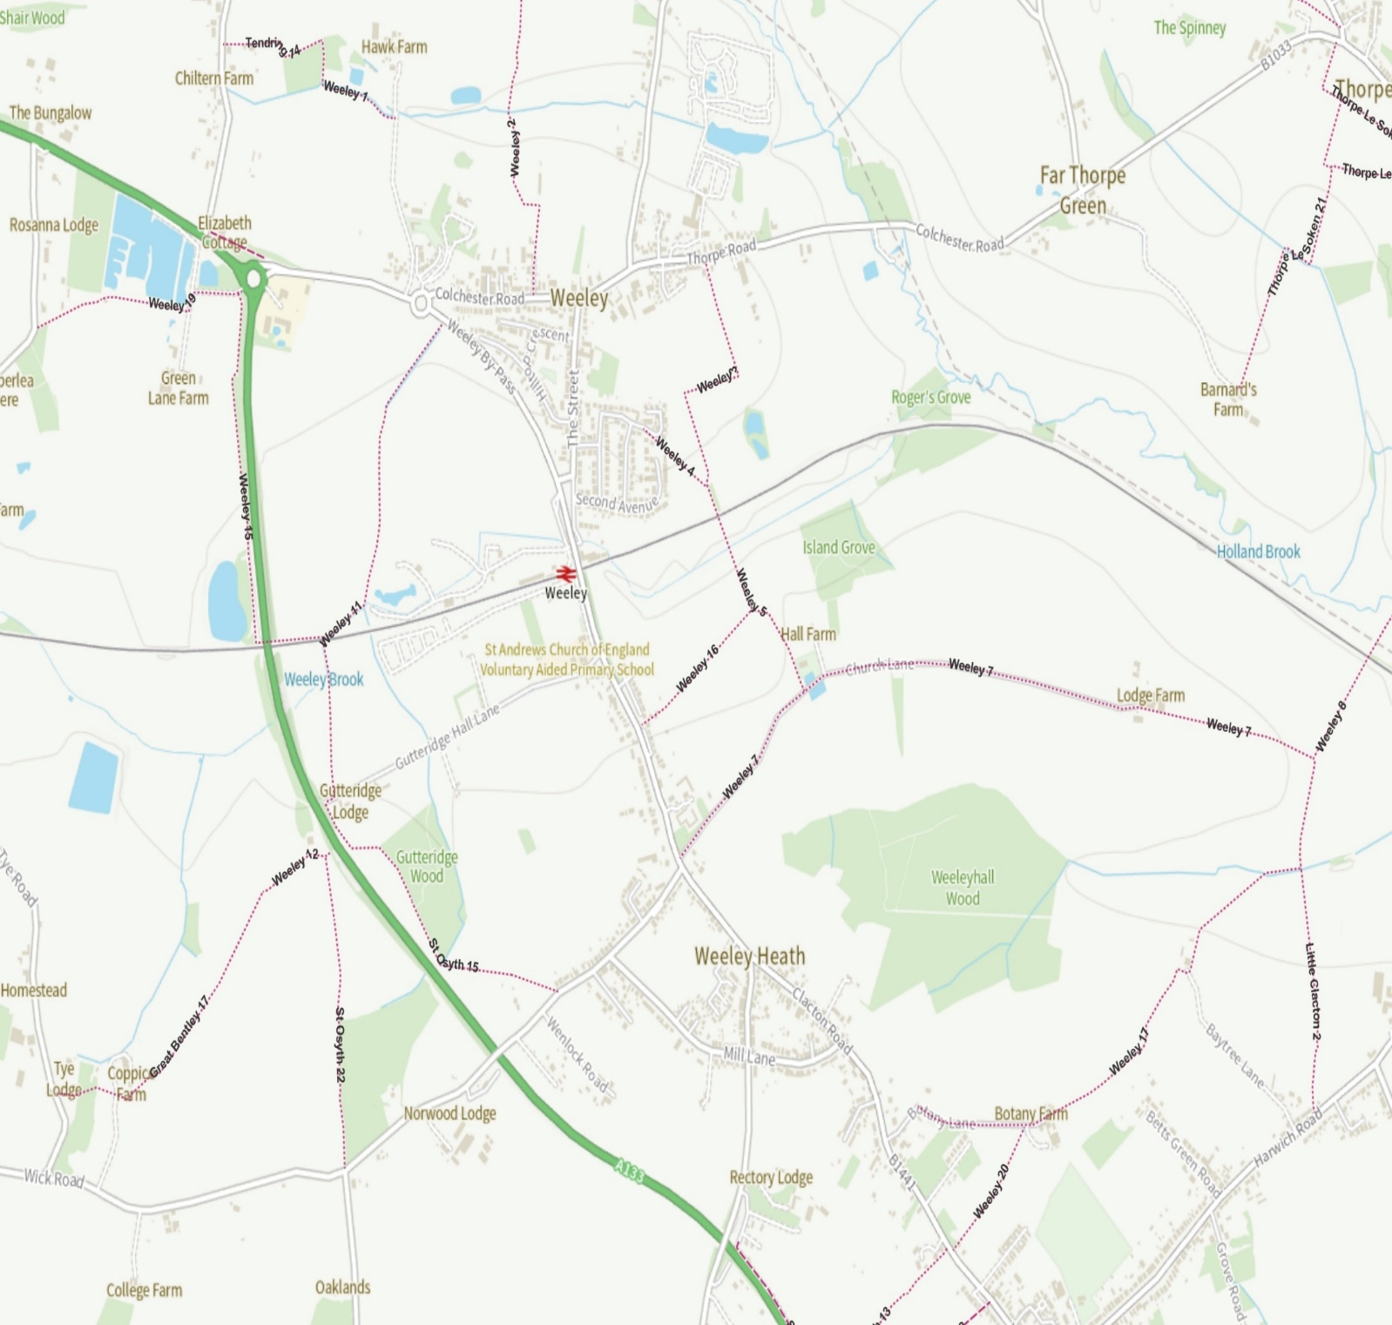

EMERGENCY PLAN UPDATES
Name | Revision date | Details of changes made | Changed by
Emergency Plan | June 2024 | Complete review of plan
Emergency Plan | January 2023 | Personnel changes and updated contact details | Christine Hamilton
Emergency Plan | November 2022 | Personnel changes and updated contact details | Christine Hamilton
Emergency plan | November 2021 | Personnel changes and updated contacts details | Christine Hamilton
Emergency plan | March 2020 | Personnel changes and updated contacts details | Nicola Baker
Emergency plan | December 2019 | Personnel changes and new deputy co-ordinator | Nicola Baker
Emergency plan | July 2019 | Changes to Councillors | Nicola Baker
Emergency Plan | July 2018 | New Emergency Co-ordinator & updated contact details | Nicola Baker
Emergency Plan & Flood and severe weather plan | January 2017 | Changes to Councillors plus new Flood and Severe Weather Plan | Nicola Baker
Emergency plan | June 2015 | Changes to Councillors and Local skills and resources | Nicola Baker
Emergency plan | May 2014 | Changes to Councillors | Nicola Baker
Emergency plan | January 2014 | Changes to Councillor details and contacts list | Nicola Baker
Emergency plan | June 2013 | New deputy co-ordinator & changes to telephone tree | Nicola Baker

WEELEY PARISH COUNCIL EMERGENCY PLAN SHEET NO:
INCIDENT SHEET/PERSONAL LOG
Name:
DATE: INCIDENT DESCRIPTION:
TIME | TO / FROM | OCCURRENCE / ACTION  (Record Every Significant Event)

Signed: _________________________________________ Date: ______________________
CONTENTS
Plan Distribution List Page 2
Emergency Contact List Page 3
Local Skills and Resources Assessment Pages 4-6
Telephone Tree Page 7
Emergency Grab Bag Page 8
Local Risk Assessment Page 9
First Steps in an Emergency Page 10
Draft Emergency Agenda Page 11
Actions in the event of an Evacuation Page 12
Weeley Parish Stret Map Page 13
Emergency Plan Update Page 14
Incident Sheet/Personal Log Page 15
Contents Page 16

