Weeley in bloom December report 2025
Good evening everyone, a very short report this month due to the time of year and the weather.
We continue to look after all areas in the village by cutting back and keeping tidy.
In the new year we will be holding a community litter pick concentrating on the area around the McDonald’s roundabout.
There is an issue with the bus stop bench opposite the memorial, I have sent you a photograph showing that the metal support on the base has snapped.
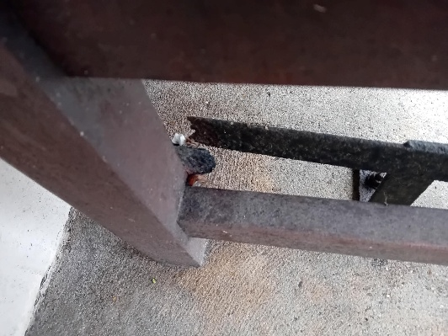

Mrs Christmas has made her 1st visit to Colchester Hospital delivering Christmas pies to the nurses which have been donated by Weeley residents. She will continue this at Clacton and Harwich hospital. Due to Weeley in Bloom getting the community involved she now has enough mince pies to go around all three hospitals, And would appreciate it happening again next year.
On Friday Wib committee enjoyed a lovely Christmas lunch at Hilltop. We chose there because they support us throughout the year and this is our way of returning the support.
We would also like to thank the parish council for organising the lighting of the Christmas tree and having the scouts and cubs decorate the tree, then joining in with the carol singing.
We wish you all a merry Christmas and a prosperous new year. You for the support this year again.

